**Day 4 Roadmap: Dynamic Frontend Components & Marketplace Features**

***Day 4***

### ****Objective****

Build and integrate dynamic frontend components for your e-commerce website, including product listings, product details, cart functionality, search, wishlist, checkout flow, and more.

### ****Step-by-Step Process****

#### ****1. Product Listing Component****

* **Purpose:** Display products dynamically with name, price, image, and stock status. 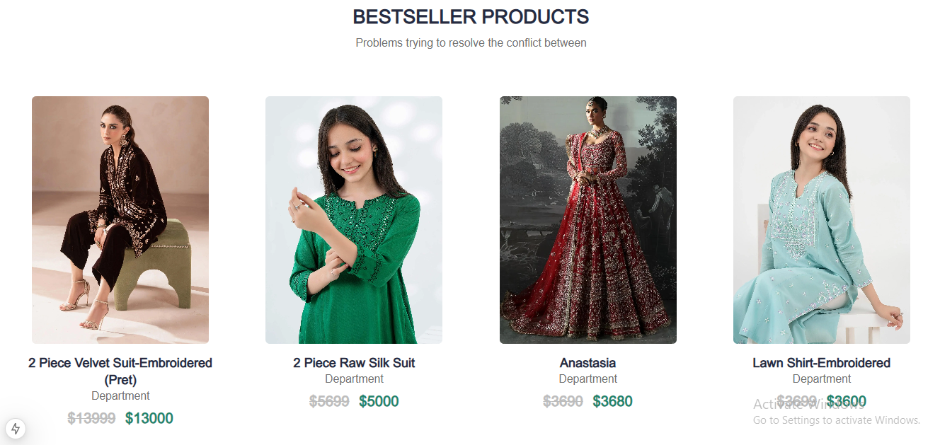
* **Implementation:**
  + Create a ProductList.tsx component.
  + Fetch product data from Sanity using GROQ queries.
  + Use a grid layout for responsive design.
  + Example:

// ProductList.tsx

export default function ProductList({ products }) {

return (

<div className="grid grid-cols-1 md:grid-cols-3 gap-4">

{products.map((product) => (

<div key={product._id} className="border p-4">

<img src={urlFor(product.productImage).url()} alt={product.title} />

<h3>{product.title}</h3>

<p>${product.price}</p>

<p>{product.inStock ? "In Stock" : "Out of Stock"}</p>

</div>

))}

</div>

);

}

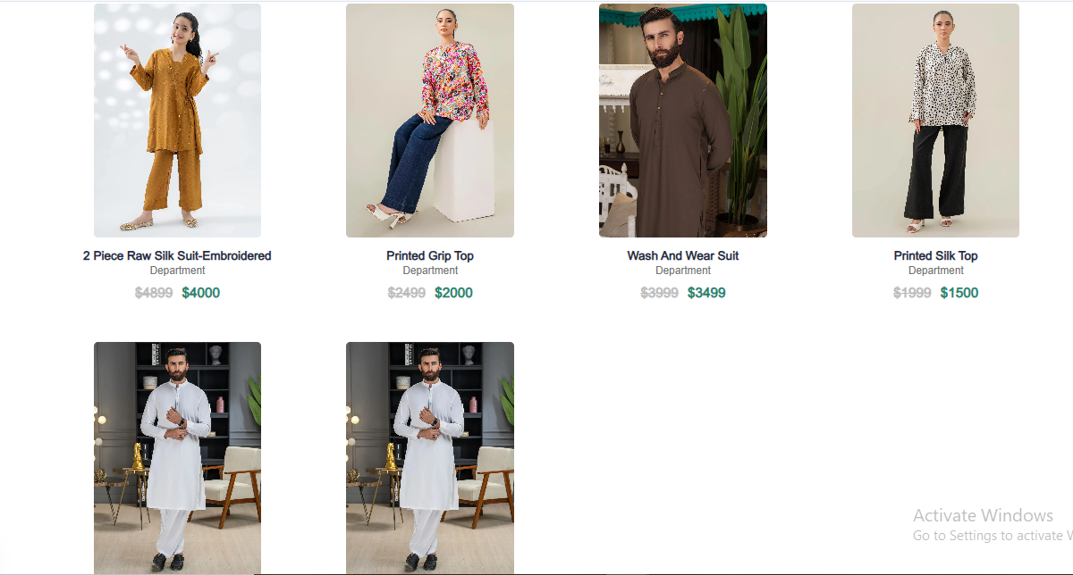

*02 Product Detail Component:*

*Create product detail page having fields image of product, description, price, sizes, colors.*

*Here I have made product detail file components fields like description, price, sizes and colors.*

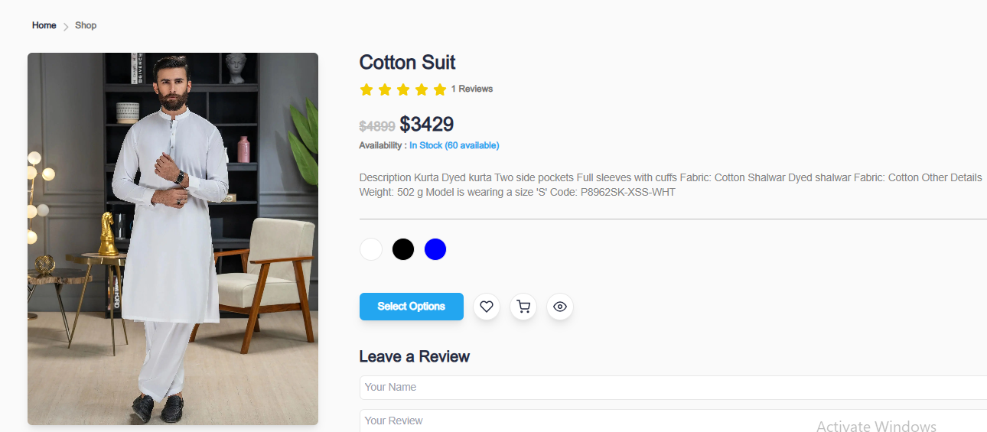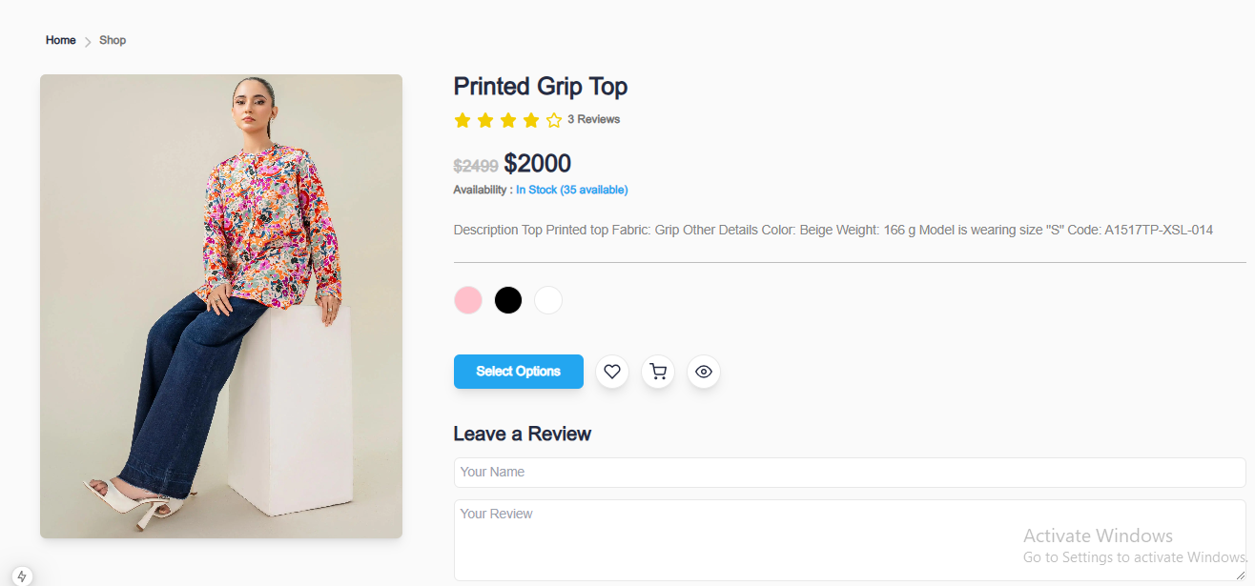

***03. Category Components:***

*Display category dynamically,*

*Filteringproducts by setting categories*

*> Man women kids and others*

*> Low price and high price*

*> popularity*

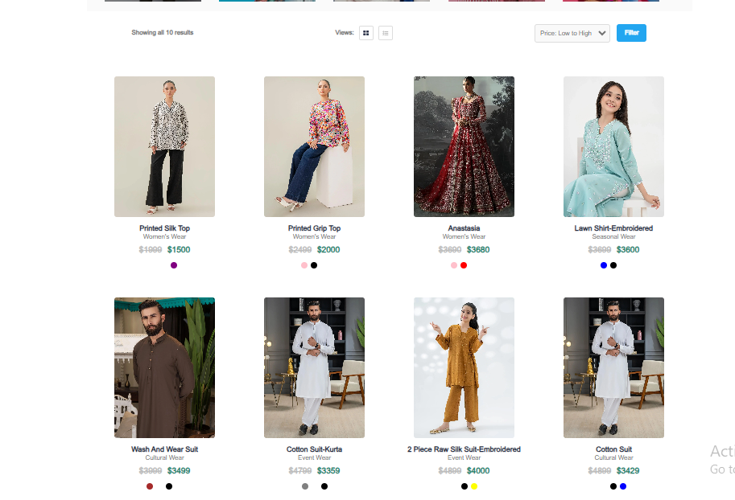

***04 Cart Component:***

*Display added items, quantity and total price.*

*Use state management for tracking cart items* 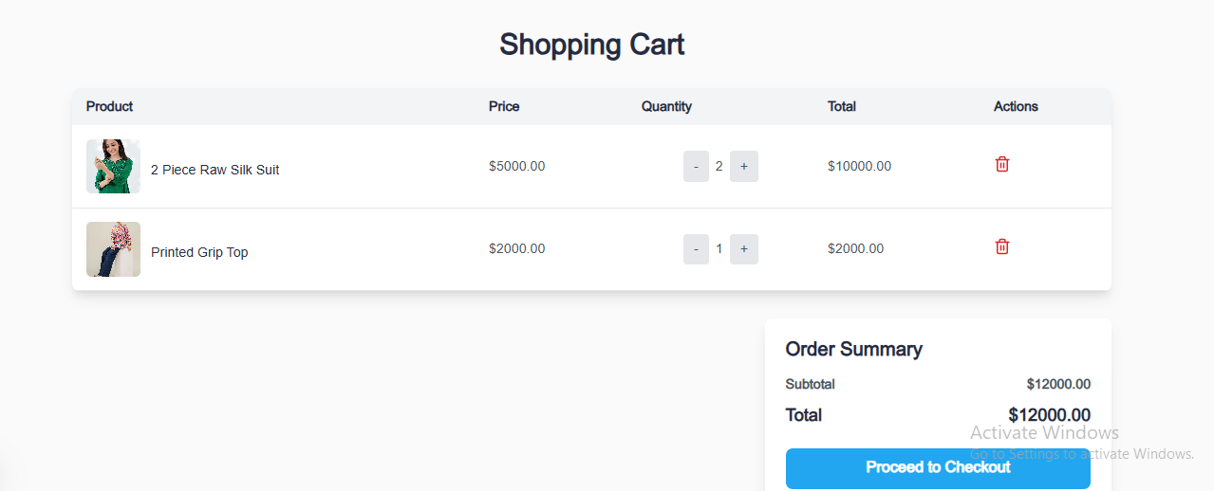

***05 Search Bar Component***

*Implementation of search functionality by filtering products by name or tags*

***search component.PNG I have search name Anastasia***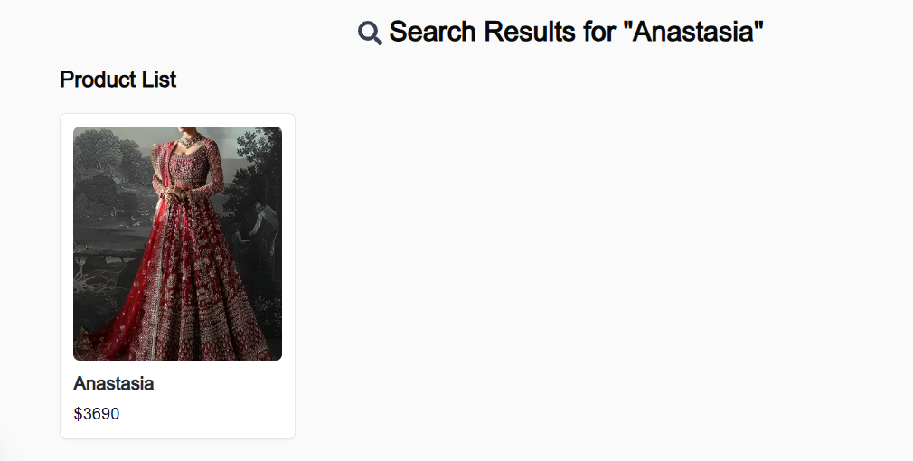

06 Wishlist Component

Allow customer to save products for future reference

Use local storage or a global state management tool to persist data.

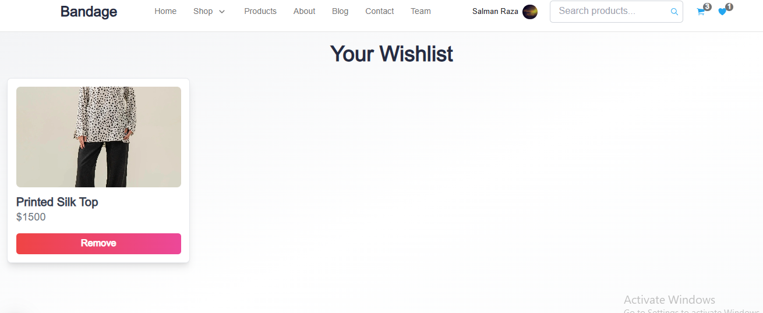

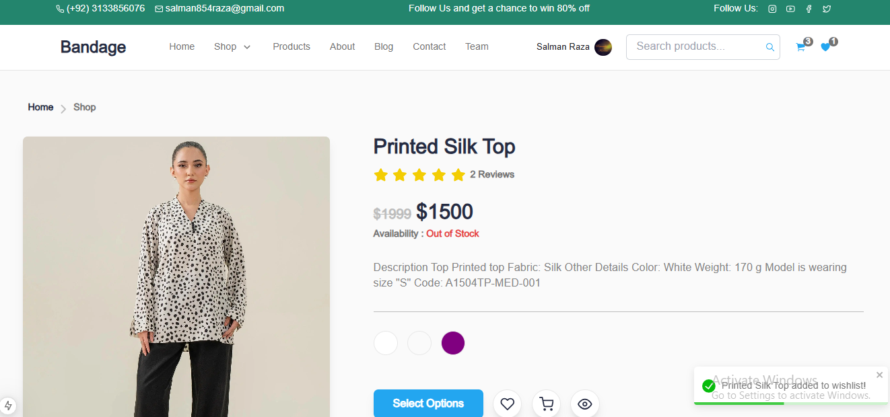

07 Checkout Flow Component

The Checkout functionality streamlines the purchase process, collecting and validating user information to finalize the order

Create a multi step form for checkout, including fields for:

Billing and shipping address

Payment data (mock implementation)

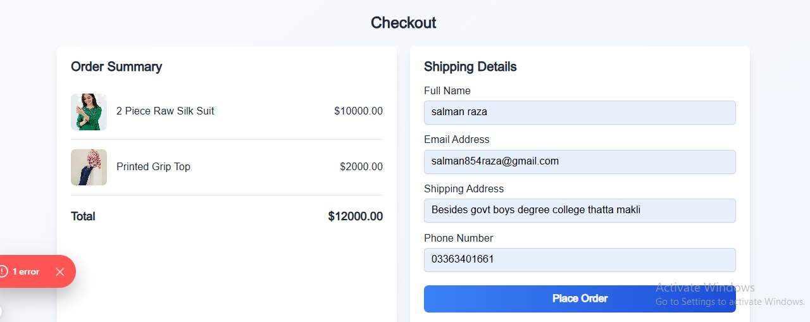

Detailed Description:

* The checkout process is devided into multiple steps: billing details, shipping address, and payment information.
* A dynamic progress tracker indicates the current step, enhancing the user experience.
* Input validation ensures that all required fields are filled correctly, reducing errors during order submission.
* Although payment integration can be mocked initially, it is designed to be extendable with payment gateways like Stripe or paypal.
* Order summaries are displayed at the end, allowing users to confirm their details before finalizing the purchase.

Price Calculation

Price Calculation dynamically computes the total cost of items in the cart,factoring in taxes, discounts and other adjustments.

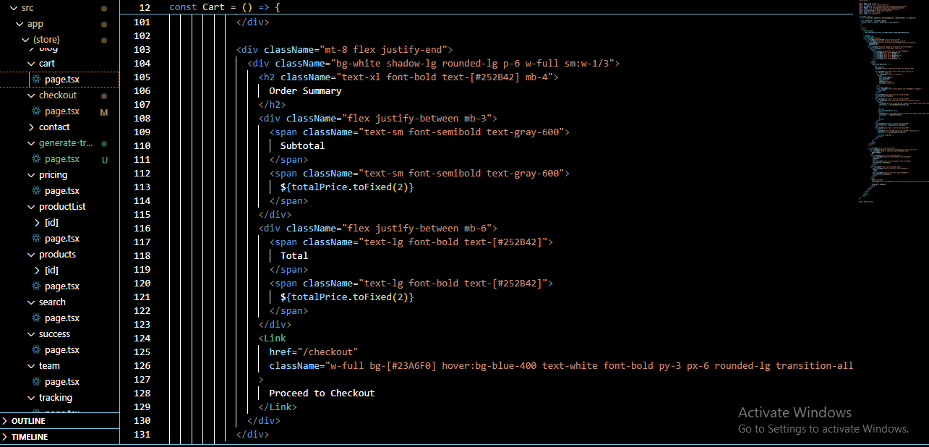

Detailed Description:

* The subtotal updates in real-time as items are added, removed, or quantities are adjusted.
* Taxes and discounts are calculated dynamically based on predefined rules, offering flexibility to apply promotional codes.
* The calculation logic is optimized to handle multiple scenarios, such as bulk discounts or tired pricing.
* This functionality improves transparency by breaking down costs, giving users a clear understanding or the final price.

08 Pagination

Break down products list into manageable pages

Implementation of previous or next buttons or number of pagination

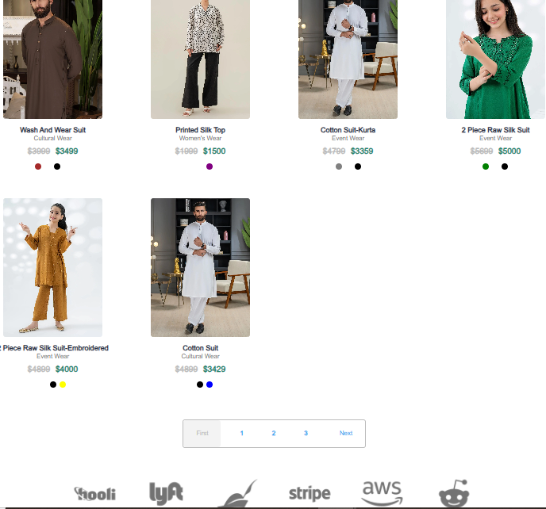

09 Filter Panal Component

Provide advanced filtering options such as:

Price range sliders

Brand selection

Availability toggles (e.g “in stock” only)



10 Order Tracking Component

Provide real-time updates on order status, including estimated delivery and location.

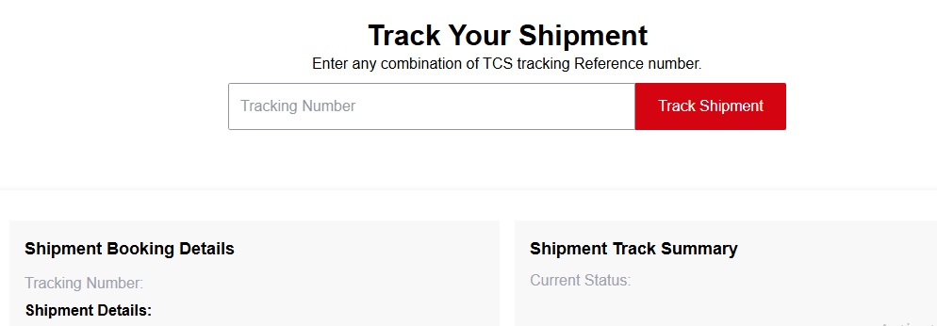

**[Home Page] → [Product List] → [Product Detail]**

**↓**

**[Cart] → [Checkout] → [Order Tracking]**

**↓**

**[Wishlist]**

### ****Key Deliverables for Day 4****

1. **Dynamic Components:**
   * Product List, Product Detail, Cart, Wishlist, Checkout, Pagination, Filter Panel, Order Tracking.
2. **State Management:**
   * Use **Context API** or **Redux** for cart and wishlist.
3. **Responsive Design:**
   * Ensure all components are mobile-friendly.

**The End**